FORMAT LAPORAN PAKTIKUM DASAR PEMROGRAMAN

*\*FILE NAME =ABSEN_NAMA _KELAS _MINGGU-1*

*\*minggu menyesuaikan minggu ke berapa\**

**2. 1 Percobaan 1**

*\*bukti percobaan dengan melampirkan screenshoot kode program yang telah dihasilkan\**

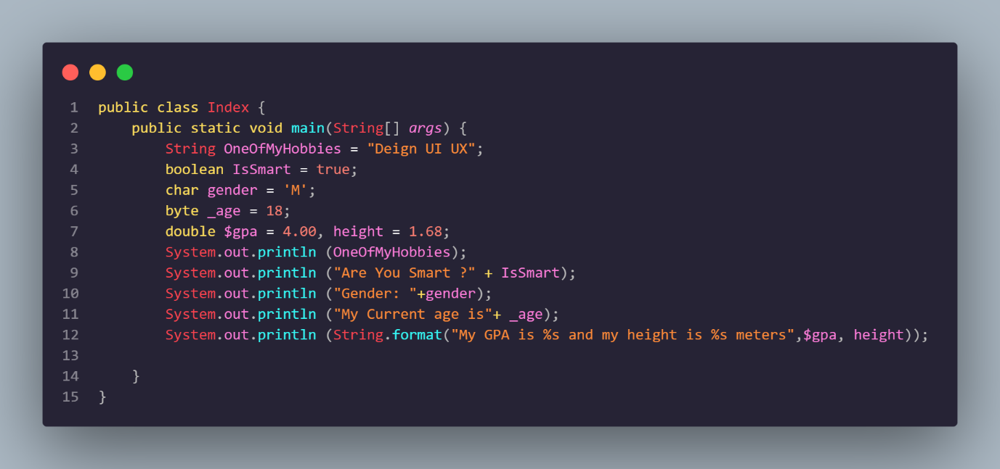

**Pertanyaan :**

1. Change the variable name so that the variable naming model is good and correct!

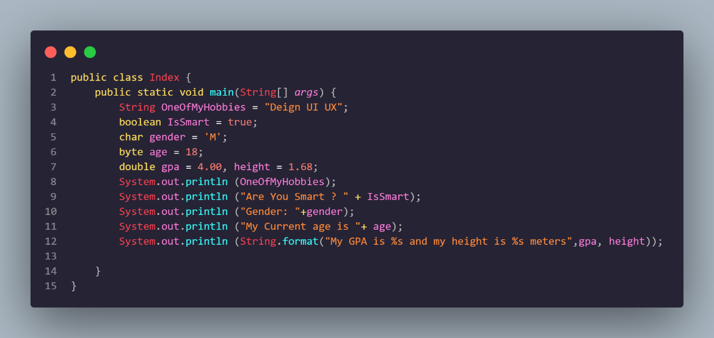

1. What is the function of %s in the statement below?

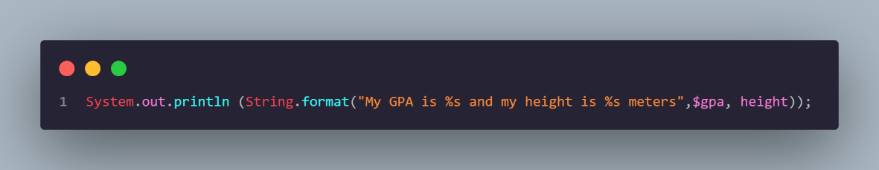

Answer: "%s" in Java is not a function but a placeholder used for string formatting.

**2.2 Percobaan 2**

*\*bukti percobaan dengan melampirkan screenshoot kode program yang telah dihasilkan\**

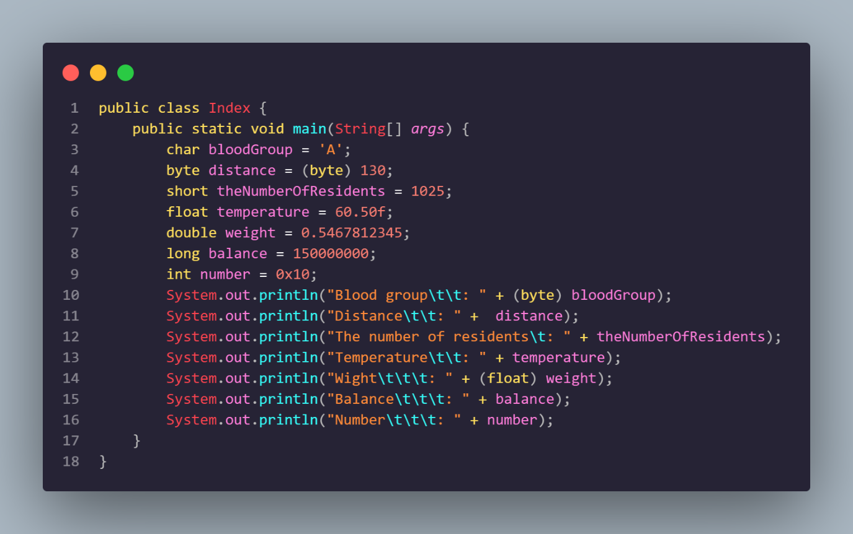

**Pertanyaan :**

1. Explain why the **bloodGroup** does not display an "A"!

Answer: because it exists (bytes) the result displayed is A but it has been converted to a decimal value according to ASCII.

1. Explain the meaning of **byte distance = (byte) 130**! Then, explain why the results change when displayed!

Answer: Distance byte code = (byte) 130; Java is an example of the casting process on the byte data type. The reason why When displayed the results change is because bytes in Java have a range of values

-128 to 127. Meanwhile, the existing value exceeds the existing value range so an overflow occurs and it is wrapped back to the lowest value, namely -128, then added by 2 to get a value of -126.

3. In the syntax **float temperature = 60.50F;** remove the letter **F**, then run again. What happened?

Answer: When the letter F is omitted, Java will automatically treat the float number as a double number so that the program code cannot be run because it cannot convert from double to float.

4. Why does the result change when displaying weight values?

Answer: Because there is (float) the existing value experiences a narrowcasting from double to float. This is also because double uses 64-bits while float only uses 32-bits so double has a larger capacity for storing decimal numbers compared to float.

5. Explain the meaning of initializing **0x10** on **number** variables! What does it do?

Answer: The purpose of initialization 0x10 is to initialize a variable with a value in hexadecimal form (base 16), in the code above 0 is a prefix that indicates the next value will be displayed in hexadecimal number while 10 in hexadecimal is equivalent to 16.

**2.3 Percobaan 3**

*\*bukti percobaan dengan melampirkan screenshoot kode program yang telah dihasilkan\**

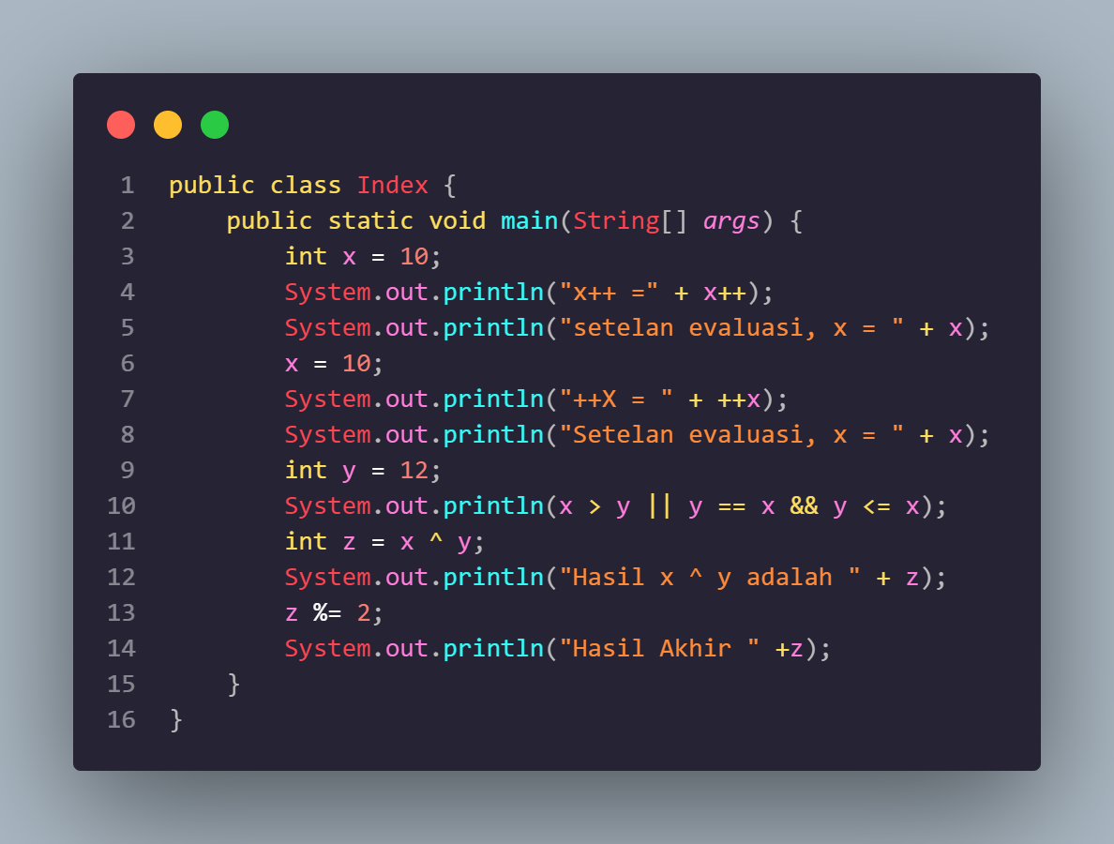

**Pertanyaan :**

1. Jelaskan menurut pendapat Anda perbedaan antara x++ dan ++x ? Jawab : Perbedaan antara x++ dan ++x terletak pada kapan nilai lama atau baru dalam kode program itu digunakan. Pada x++ nilai ditambahkan setelah pernyataan dijalankan sedangkan pada ++x nilai ditambahkan sebelum pernyataan dijalankan.

2. Berapa hasil dari int z = x ^ y; , silakan dilakukan perhitungan secara manual!

Jawab : Tanda ^ pada operasi di atas berate XOR . XOR menghasilkan nilai di mana pada setiap bit akan bernilai jika satu dari dua bit tersebut adalah 1 (atau 0 jika keduanya sama)

X = 1011

Y = 1100

Sehingga x ^ y akan menjadi 0111 yaitu 7

**2.4 Percobaan 4**

*\*bukti percobaan dengan melampirkan screenshoot kode program yang telah dihasilkan\**

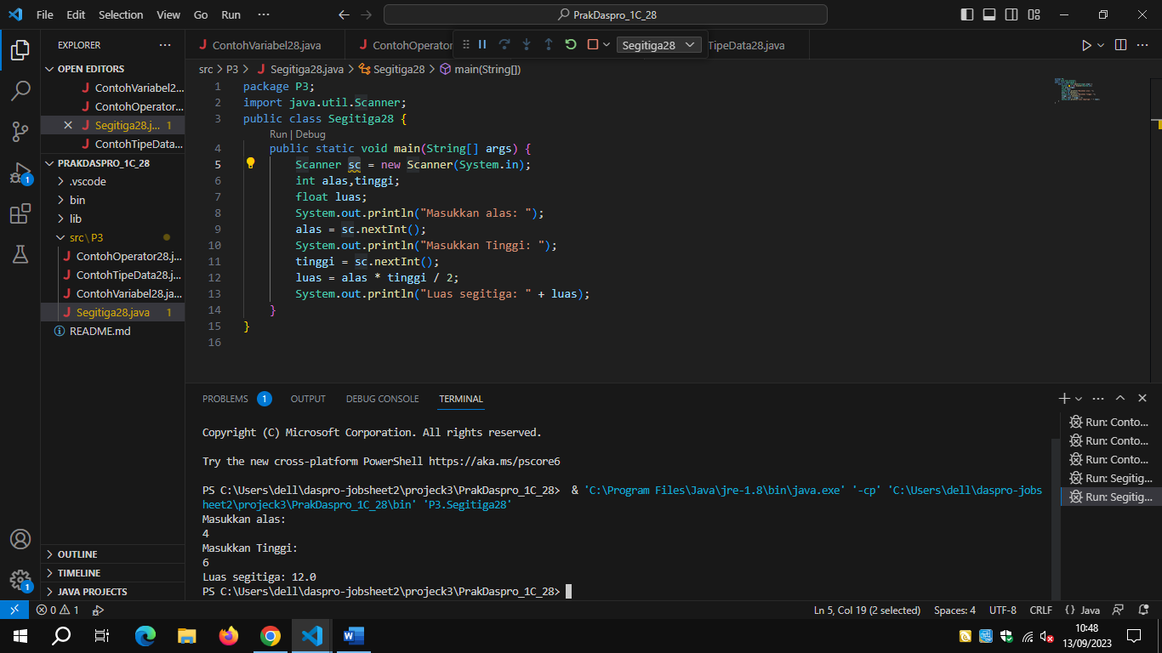

Pertanyaan:

1. Explain why you have to make a Scanner declaration in practical experiment 4 above? Answer: The Scanner declaration must be done so that we can use the Scanner object to take input from us or read data from various sources such as the keyboard.

2. Explain the use of the program pieces below! Answer: The use of the program snippet base = sc.nexInt() above is to take our input number and initialize its value into the variable base. Likewise with program pieces

tinggi = sc.nexInt()

Alas = sc.nextInt();

Tinggi = sc.nextlnt();

Jawaban:

**2.5 Percobaan 5**

*\*bukti percobaan dengan melampirkan screenshoot kode program yang telah dihasilkan\**

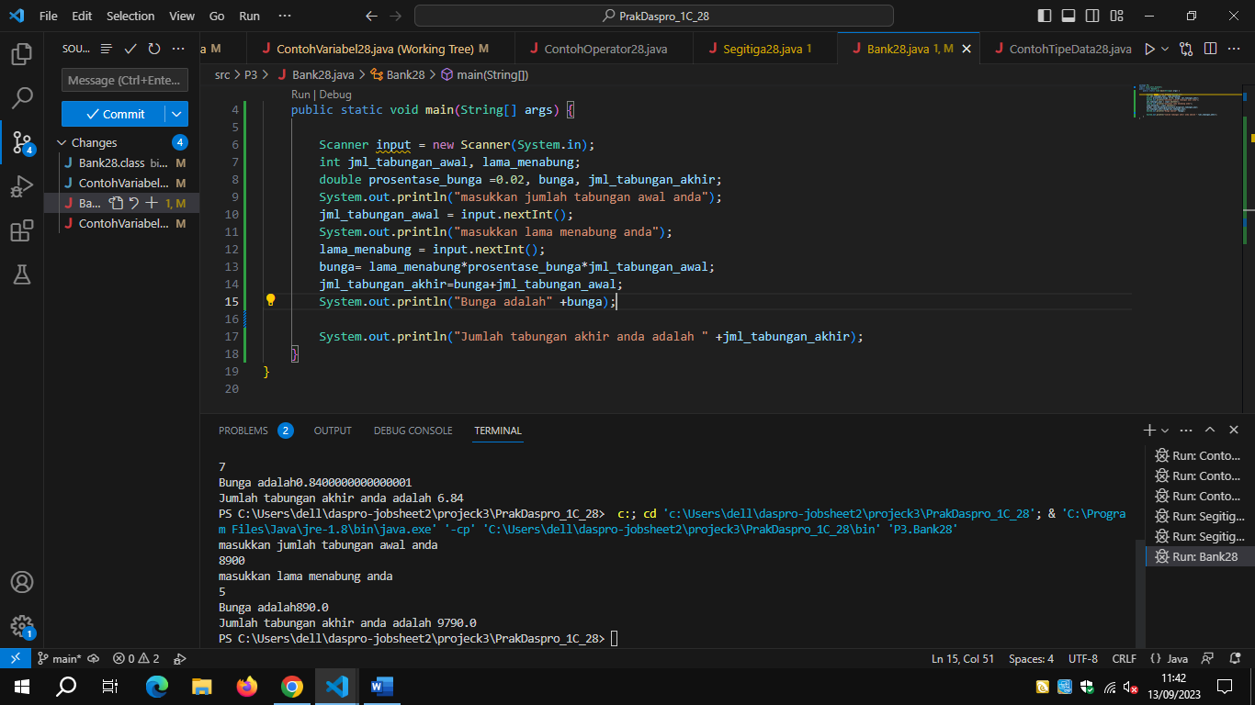

Tugas